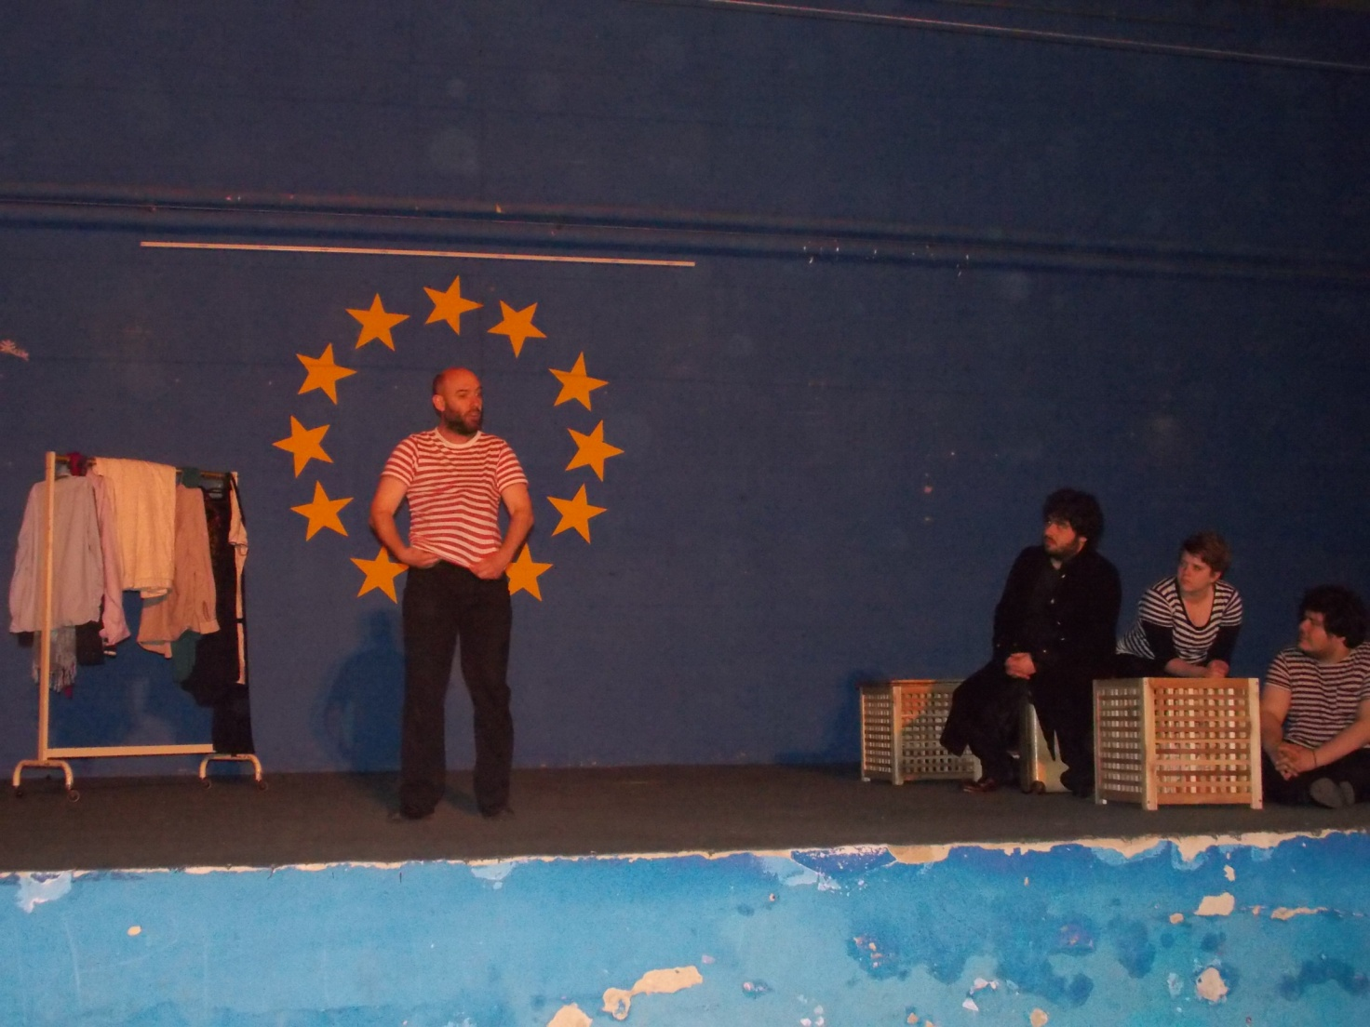

On the 10th March 2014 we attended the second meeting of the project about Shakespeare and his theater. The team was composed by three British actors (two men and a woman) that played Shakespeare the same way they were played at that time. All this with the collaboration of an Italian actor who had the role of narrator. A “today-traditional” theater. It was a particular representation of different scenes of Shakespeare’s plays. The mix included these works: Romeo and Juliet, perhaps the most popular tragedy of love; Macbeth, the shortest Shakespeare’s tragedy; Twelfth night, a comedy; A midsummer night’s dream, a comedy composed by interwoven and funny stories. A particularly pleasing effect was reached by a game with a small ball accompanied by music. All songs were written for the performance by an Italian composer who, at the end of the show, explained us how music can evoke different emotions just adding or removing some notes. It was an exciting experience that we would like to repeat. (Class IVA ITG Nervi)

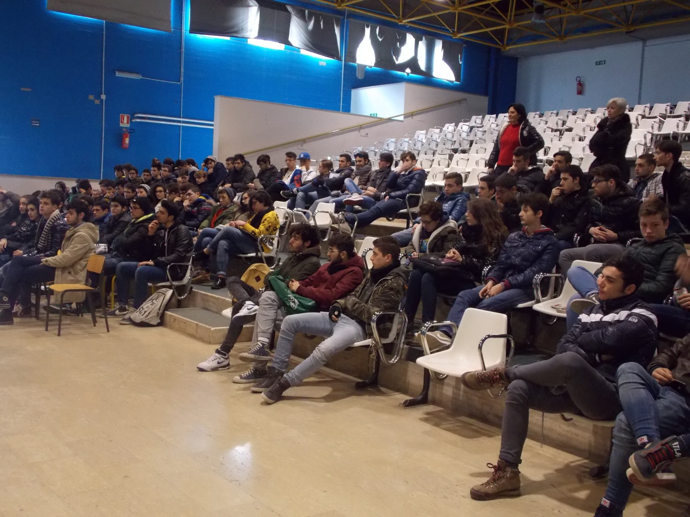
The theatrical project called Staging Shakespeare is an impressive journey into Shakespeare's drama. In the show an Italian actor plays the role of “Virgil” guiding the audience in some of the most important scenes from the corpus of the works of the Bard. The real protagonist of the scene is the polysemic "word", which is able to evoke and tell, to explain and describe. As it is, word might be considered as the only true star of a theatre that still stands motionless in the heart of the Time. The show can be considered very innovative, because of the pleasant interaction between the audience and the theatre scene. The actor who mostly impressed us was the one who played the role of the lion. (class 4^ A chim. ITIS G. Galilei)

Thanks to the brilliant performance of the acting company we got a sense of what the theatre was like in Shakespeare’s days so we made familiar with the theatrical language used in Shakespeare’s plays that is rather different from the contemporary theatrical language. Besides, we were astonished to discover just how contemporary, vivid and playfully fulfilling these plays are. We particularly liked the performance of the musician who showed us the way music is able to affect our mood. (class 4^ B chim. IT IS G. Galilei)

